**CL-1002**

**Programming Fundamentals - Lab**

**Lab # 15**

|  |
| --- |
| **Objectives:**   * Loops/Nested Loops * 1D arrays * 2D arrays * Strings * C-Strings /Character arrays * Functions * File handling * Practice tasks |

**Note: Carefully read the following instructions (***Each instruction contains a weightage***)**

1. Use proper **font family** and **font size** of **heading**, **sub heading** and **normal text**.
2. First think about statement problem then write/draw your logic on copy.
3. Attach the screen shots of your code in word file with execution (cpp project).
4. File (Word) tittle should in proper format (**23F-1001-Lab2**)
5. You have to submit both (**word + Project in zip/archive**) files.
6. **Upload archive/zip of your project.**
7. **80% marks would be deducted on wrong formatting.**
8. **No submission will be accepted after deadline.**
9. Do not copy from any source otherwise you will be penalized with negative marks.
10. Complete your lab **within given Time Slot**.

**Problem: Write C++ code for the following statements**

1. **Write a C++ program that create two following functions: (Marks 5)**

**1*. void SquarePbyV(int);* //Function 1**

**2. *void SquarePbyF(int&);* //Function 2**

**You need to get an integer value from user and then pass value as a parameter one by one to both functions to get the square of the value. You need to make 4 function calls as per the given order, and also cout the integer value in main after each function call you make:**

**• Function 1**

**• Function 2**

**• Function 1**

**• Function 2**

**Sample Input: Enter the number: 2**

**Expected Output:**

**Square from function1: 4**

**Value from main: 2**

**Square from function2: 4**

**Value from main: 4**

**Square from function2: 16**

**Value from main: 4**

**Square from function1: 16**

**Value from main: 16**

1. **Write a C++ program that will create two same size arrays of Size 10, then you need to fill the both arrays by taking values from user. You need to pass these two arrays to function**

***int SimilarCheck(int[ ], int[ ])* that will compare the both elements of arrays with each other’s and should return the count of elements which are common in both arrays. (Marks 5)**

**Let’s Assume:**

**int ArraysA = {1,2,3,4,5,6,6,7,8,9};**

**int ArraysB = {1,2,3,4,5,6,6,7,8,10};**

**Expected Output:**

**Common Elements are: 9**

1. **You need to implement this problem using functions, you are only allowed to declare and initialize variables/arrays and function call in main. Rest off all logic should be in function including taking input from user and other requirements.**

**This program can be used to assign seats for a commercial airplane. The airplane has 13 rows, with six seats in each row. Rows 1 and 2 are first class, rows 3 through 7 are business class, and rows 8 through 13 are economy class. Your program must prompt the user to enter the following information: (Marks 10)**

**1. Ticket type (first class, business class, or economy class)**

**2. Desire seat Number**

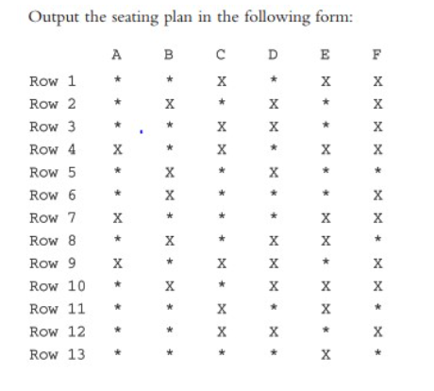

**Here, * indicates that the seat is available; X indicates that the seat is occupied. Make this a menu driven program; show the user’s choices and allow the user to make the appropriate choices.**

**Note: If seat already occupy show the proper message and then say choice again, and need to do all other exception handlings.**

1. **A person can have the following attributes - name, age, salary and experience. Name and age remain same throughout the code but salary change from organization to organization. Initially experience is zero (0) and after joining organization it can increase by(1).  
   Your task is to create a function name organization, access it multiple times from main() and show attributes after each call in built-in function. (use static, local and global variables) (Marks 10)**

**Example:**

**Name- Ali**

**Age- 22**

**Salary – 151000 (assign any number initially, salary should by increased by 10% in built-in function)**

**Experience – 0 (initially, but increase 1 point after each function call)**

1. **Write a C++ code that calculates factorial of a given number recursively (Marks 10)**
2. **1. Write a C++ program that opens an already created file firstfile.txt (that you have created in above question). (Marks 10)**

**2. Now read the data of file and display it. (Read the data until you reach end of file).**

**3. Now remove all the text from file.**

1. **Write a C++ program that write in a file firstfile.txt your name, roll number and CGPA. (Marks 10)**

**Example:**

**Name: XYZ**

**Roll Number: 23F-1111**

**CGPA:3.89**

1. **You need to create your character dictionary we can called “Char Dict” using the concept of the file handling. (Marks 20)**

**1. Dictionary Initializations:**

**a. You need to generate 100 random characters both (Upper Case and Lower Case) and then you need to store in file, you can create text file and name as dict.txt**

**2. Character Count**

**a. You need to create two function myUpperCase and myLowerCase.**

**b. myUpperCase will read only Upper-Case Characters from the file and display.**

**c. myLowerCase will read only Lower-Case Characters from the file and display.**

**3. Update Dictionary**

**a. You need to ask from user if he/she want to update any character from the user.**

**b. Let suppose user want to update ‘C’ character then in file all ‘C’ should be updated with the new character provided by the user.**

**4. Display Content**

**a. You need to implement function that can show the whole data from the file, whenever user need.**

**5. Dictionary Size**

**a. You need to create function that can display the size of whole dictionary to user. Note: In this task you need to make the UI/UX also in the best way, it is also included in grading.**

1. **Write a Program that take 5*5 array from user and perform selection sort and bubble sort on it. (Marks 30)**

---------------------------------------------------------------------------

Best of Luck 

***"It is better to fail in originality than to succeed in imitation." — Herman Melville***